Question:
(a) Choose a programming language with which you are familiar and identify one of the semantic rules of that language. Give an example of a program in that language that violates that rule. Post a screen shot showing the error message that the compiler for that language would generate for your program example.

Programming language chosen : DART

Dart is a statically-typed programming language, which means that all variables must be declared with a specific type before they are used. Additionally, in Dart, variables can be either nullable or non-nullable.
A nullable variable is a variable that can have a value of null or a valid value of its declared type. A non-nullable variable is a variable that must always have a valid value of its declared type and cannot be null.
One of the semantic rules of the Dart programming language is that all non-nullable variables must be initialized before they are used. This means that if you declare a non-nullable variable and do not assign a value to it, the Dart compiler will raise an error.
Here's an example program that violates this semantic rule:
Dart Program:

void main() {

int variable; //integer variable is not initialized
print(variable);

}
In this program, the integer variable variable is declared but not initialized. Since variable is declared as a non-nullable integer variable, the Dart compiler requires that variable be initialized with a valid integer value before it can be used.

This program is syntactically correct but semantically wrong.

When you try to run this program, the Dart compiler raises an error with a message that clearly indicates that x must be initialized before it is used. In the error message, the caret symbol (^) is pointing to the line where x is declared, indicating that the error occurred at that line.
Error:
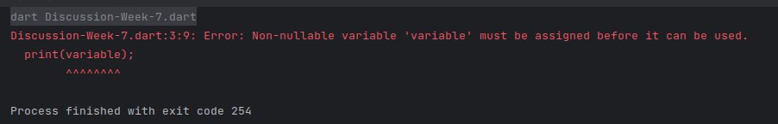

Solution:
To fix this error, you can initialize variable with a valid integer value before using it, as shown in the corrected example program I provided earlier. This way, variable will have a valid value before it is used, and the program will run without any errors.

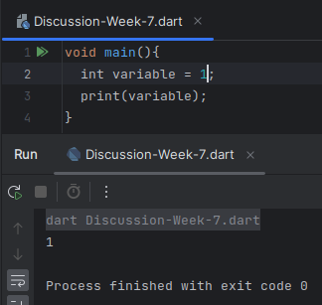

(b) Then review the requirements for project 4. Select one of the semantic errors that you are to detect in project 4 and provide a test case that will detect it.

Semantic Error Chosen from Project 4:

If Condition Not Boolean
Test Case:

-- Comprehensive test with nested if

function main a: integer, b: boolean, c: real returns integer;
d: integer is 8;
e: real is 3.75;
f: boolean is true and not b;
begin
if a > 5 and a < 1 and c = 5. or c /= 8.E4 or f or d + e then
if c >= 7.E-2 and c <= 5.2 or false then
a + 2 - 7.E+2 / 9 * 4;
else
a rem 2 - 5 / c;
endif;
else
a ** 2 rem 3;
endif;
end;

Error:

The given test case fails the IF-Boolean rule because it contains a non-Boolean expression in the condition of the first if statement. Specifically, the expression d + e is not a Boolean expression, as it evaluates to the value 11.75, which is a real number.

The IF-Boolean rule states that the condition of an if statement must be a Boolean expression, which means that it must evaluate to either true or false. In the given test case, the condition of the first if statement includes the non-Boolean expression d + e, which violates this rule.

If I convert this test case into Dart, we detect an error of IF condition not being a boolean error.

Dart code:
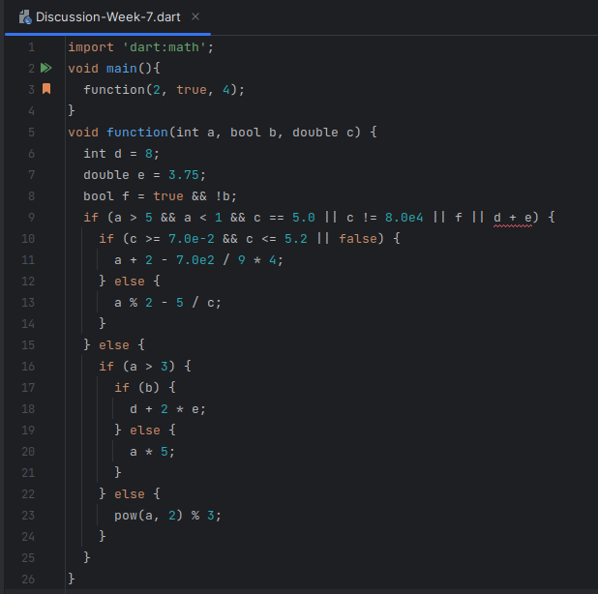
Error:
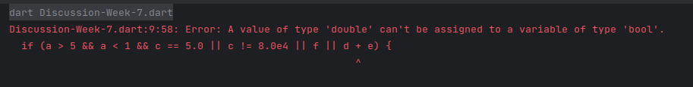

References:

- "Dart Language Tour." Dart, https://dart.dev/guides/language/language-tour#variables.
- "Dart Programming Language Specification." Dart, https://dart.dev/guides/language/spec.
- "Dart Static Types." Dart, https://dart.dev/guides/language/type-system.

